Nmap Scan

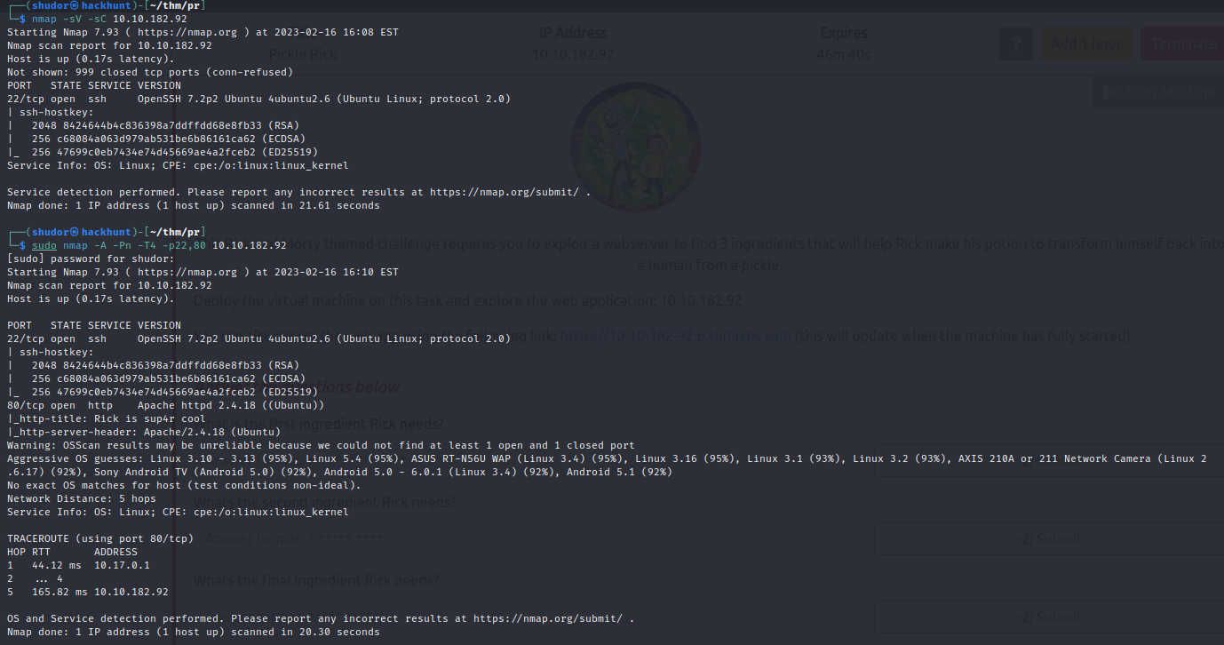

Nikto Scan

Gobuster Scan

After scanning using gobuster we got the directories login.php page

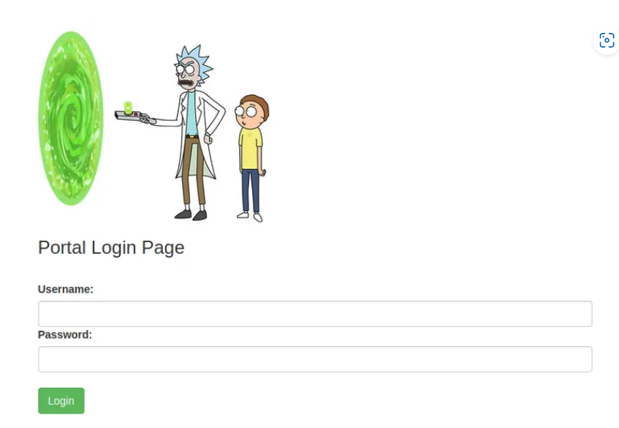

We logged in using the username R1ckRul3s and password Wubbalubbadubdub

Now we start using this command panel

What is the first ingredient Rick needs?

Whats the second ingredient Rick needs?

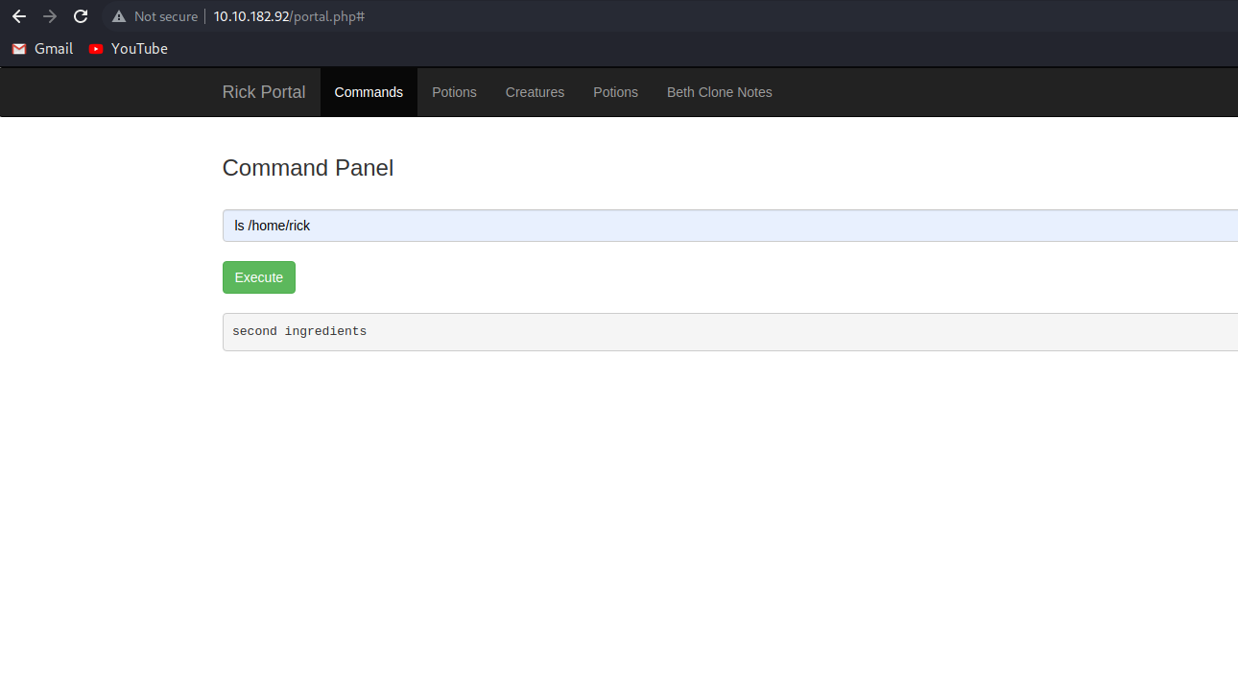

Whats the final ingredient Rick needs?



